

**Reviewing Policies and Procedures**

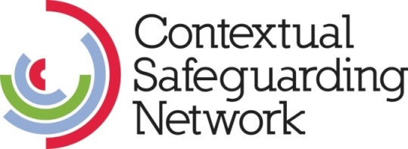

**Policies and Procedures Review**

This guidance forms part of the Beyond Referrals audit toolkit and should help schools audit their responses to harmful sexual behaviour (HSB). This guidance outlines one method that can help a school complete their beyond referrals audit – reviewing policies and procedures.

# Reviewing policies and procedures

Policies and procedures are the documents outlining the systems in place within schools to prevent and response to harmful sexual behaviour and other safeguarding concerns. Whilst all schools should have a safeguarding policy and procedure outlining the schools response to safeguarding concerns, some schools also have particular sections of this policy or separate policies and procedures focused on particular forms of harm, such as HSB.

Reviewing policies and procedures provides an opportunity for schools to review what their response to HSB is on paper. This process enables schools to identify where HSB is positioned within the school’s safeguarding response and how it relates to other forms of harm, as well as any gaps or inconsistencies within the policies. It also enables schools to see how their policies and procedures are aligned with the policies and procedures in the wider partnership, identifying any inconsistencies.

The person that carries out the review should sit within the safeguarding team. The review should include reading through the schools policies and procedures. It might also be useful to consider a range of incidents and see if you policies and procedures provide clear guidance on how to respond to these cases.

**Review process**

Once you read through the policies and procedures you may want to take notes. When doing this you may want to consider the following questions:

1. **Are the policies clear and easy to follow?** Are there any gaps within the processes outlined? Would any member of staff be able to understand and follow the policies? Are they accessible to parents and pupils?
2. **Clear referral routes:** Does your policy outline processes for both internal referral process, as well as external referrals process for local authority safeguarding partnership?
3. **HSB/Peer on Peer abuse policy**: is there a section within your policy or does your school have a standalone policy that focuses on peer-on-peer abuse or harmful sexual behaviour? Does this section/policy provide information and procedures for the continuum of harmful sexual behaviours, ranging from inappropriate and problematic sexual behaviours to those considered abusive and violent? Do your policies and procedures provide a definition of HSB within these documents?
4. **Welfare and safeguarding**: is your harmful sexual behaviour response located within your safeguarding policy and procedures. Is this the case for all forms of harmful sexual behaviour including inappropriate or problematic behaviours? Do your policies and procedures outline a safeguarding response for both victims and those instigating harm.
5. **School culture**: do your policies and procedures only provide guidance for individual incidents of harmful sexual behaviour or do they also provide responses to more contextual factors within the school environment. For example, do you provide guidance regarding addressing harmful gender norms and attitudes within peer groups or the wider school body?
6. **Partnership**: are your policies and procedures aligned to those in the partnership? Are there any gaps or consistencies between your school’s policies and procedures and those within the wider partnership?